Technical Architecture:

IBM Cloud Project Design Phase-II Technology Stack (Architecture & Stack)

|  |  |
| --- | --- |
| Date | 24 October 2022 |
| Team ID |  |
| Project Name | Project - xxx |
| Maximum Marks | 4 Marks |

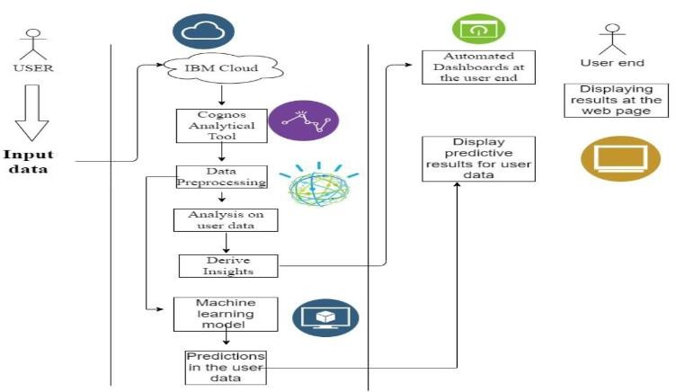

Table-1 : Components & Technologies:

|  |  |  |  |
| --- | --- | --- | --- |
| **S.No** | **Component** | **Description** | **Technology** |
| 1. | User Interface | User uploads the csv or excel format file into the web page | IBM Cognos, Python |
| 2. | Application Logic-1 | The user data will pass into the IBM cloud for storing and acts as a data source | IBM Cloud |
| 3. | Application Logic-2 | In Cloud, data will be fetch by the Cognos analytical Tool for data analysis | IBM Cognos Analytics Tool |
| 4. | Application Logic-3 | The pre-trained Dashboards will be present to perform analysis on the incoming data | IBM Cognos Analytics Tool |
| 5. | Database | Data will be retrieved from the cloud | MySQL |
| 6. | Cloud Database | Database Service on Cloud | IBM DB2, IBM Cloudant etc. |
| 7. | File Storage | File storage requirements | IBM Block Storage or Other Storage Service or Local Filesystem |
| 8. | External API-1 | To perform data analysis on the user data. | IBM Cognos Tool |
| 9. | External API-2 | To build the Machine learning model for predicting or classification | Jupyter Notebook |
| 10. | Machine Learning Model | To do the predictive analysis on the input data | Predictive analysis model |
| 11. | Infrastructure (Server / Cloud) | Application Deployment on Local System / Cloud  Local Server Configuration: Using the Flask Cloud Server Configuration : IBM Cloud | Local, Cloud Foundry |

Table-2: Application Characteristics:

|  |  |  |  |
| --- | --- | --- | --- |
| **S.No** | **Characteristics** | **Description** | **Technology** |
| 1. | Open-Source Frameworks | Google Colaboratory, Jupyter notebook | Google, Anaconda |
| 2. | Security Implementations | To protect data from the unauthorized access. | SHA-256, Encryptions |

|  |  |  |  |
| --- | --- | --- | --- |
| **S.No** | **Characteristics** | **Description** | **Technology** |
| 3. | Scalable Architecture | Justify the scalability of architecture (3 – tier, Micro-services) | IBM Cloud |
| 4. | Availability | It can be accessible with the help of the cloud service such as simple storage service | IBM Cloud |
| 5. | Performance | It could handle number of requests via cloud service with the help of the IBM Cloud | IBM Cloud, Cognos analytical tool |